**SRM INSTITUTE OF SCIENCE AND TECHNOLOGY**

**DEPARTMENT OF COMPUTER SCIENCE AND ENGINEERING**

**KATTANKULATHUR – 603 203**

**15IT304J-Web Programming**

**Register Number: RA1711003011471**

**Name:Manvi Singh Chandel**

**Experiment No: 8**

**Date: 12/10/2020**

**Aim:** **Simple applications using JSP and AJAX**

**Input:**

**<html>**

**<head>**

**<script>**

var request;

function sendInfo()

{

var v=document.vinform.t1.value;

var url="index.jsp?val="+v;

if(window.XMLHttpRequest){

request=new XMLHttpRequest();

}

else if(window.ActiveXObject){

request=new ActiveXObject("Microsoft.XMLHTTP");

}

try

{

request.onreadystatechange=getInfo;

request.open("GET",url,true);

request.send();

}

catch(e)

{

alert("Unable to connect to server");

}

}

function getInfo(){

if(request.readyState==4){

var val=request.responseText;

document.getElementById('amit').innerHTML=val;

}

}

**</script>**

**</head>**

**<body>**

**<marquee><h1>**This is an example of ajax**</h1></marquee>**

**<form** name="vinform"**>**

**<input** type="text" name="t1"**>**

**<input** type="button" value="ShowTable" onClick="sendInfo()"**>**

**</form>**

**<span** id="amit"**>** **</span>**

**</body>**

**</html>**

JSP:-

**<**%

int n=Integer.parseInt(request.getParameter("val"));

for(int i=1;i**<**=10;i++)

out.print(i*n+"**<br>**");

  %>

**<?xml** version="1.0" encoding="UTF-8"**?>**

**<web-app** version="2.5" xmlns="http://java.sun.com/xml/ns/javaee"

xmlns:xsi="http://www.w3.org/2001/XMLSchema-instance"

xsi:schemaLocation="http://java.sun.com/xml/ns/javaee

http://java.sun.com/xml/ns/javaee/web-app_2_5.xsd"**>**

**<session-config>**

**<session-timeout>**

            30

**</session-timeout>**

**</session-config>**

**<welcome-file-list>**

**<welcome-file>**table1.html**</welcome-file>**

**</welcome-file-list>**

**</web-app>**

**Output:-**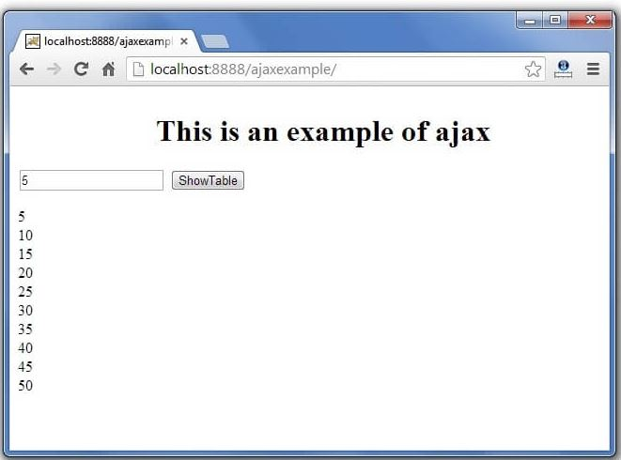

**Result: A simple application for JSP and AJAX was developed successfully**